Project idea

For our project idea we decided to further develop Hoang’s ocean robot, that sits in docks/marinas and swims around sucking up rubbish to reduce the amount of litter from the sea.

Overview

The idea for our project is fuelled by our desire to help the planet and inspired by Roombas (yes, the machine that vacuums your house). We think an AI controlled floating vacuum that sits in docks/marinas that swims around and sucks up any rubbish on the ocean’s surface would be a pretty cool and beneficial project. The idea would have a floating robot that is limited to perimeters set by the users in an area with calm waters. For example, in a local dock, the user would set borders for the robot to swim within, like Roombas sensors, for the robot to go around and suck in rubbish and litter around the dock.

Motivation

Our motivation behind this project should be on everyone’s minds! The earth is our home and it’s becoming increasingly polluted everyday of every year. Each yeah, according to conservation.org , 8 million metric tons of plastic is dumped into the ocean. By 2050, it's estimated that the oceans' plastic will outweigh all the oceans' fish. More plastic means fish, our foods, will eat more and more microplastics and in turn we will be consuming plastic from consuming the fishes. More plastic promotes the growth of algae which consumes the water's oxygen, which leaves behind dead zones where marine life dies as a result of the lack of oxygen consumption.(Conservation International n.d.) Although 1 robot in a dock would make only a tiny impact in the issue, it’s still an impact, and every bit counts. Although now this is just a project idea, theoretically, if there were multiple robots, the positive impact would grow.

**Description and Tools/Technologies Required**

The robots design features and tools required to operate and the details behind how those tools would translate into its features are as follows:

* User placed/installed sensors to mimic virtual walls for the robot to swim between. This virtual wall would prevent the robot from swimming out into rough open waters where big waves would damage the robot. The sensors would communicate via infrared signals that would define the borders the robot would be able to operate within. The user would provide a minimum of 4 sensors that are placed strategically around the dock to define the walls of the robot.
* The robot would also contain a gyroscope sensor to determine whether the water it’s on is calm enough to be on. If the gyroscope rotates all over the place, it will be programmed to return to its docking hub or wait in its position until safe to travel.
* In the event that the robot is unable to return to its hub, (e.g., low power, unable to drive through rough waters), a message would be sent to the user to signal a rescue of the robot or otherwise fix the issue.
* The robot would also be surrounded/covered by soft bumpers to prevent it from damaging itself on hard services as well as damaging any property.
* Now, we aren't marine biologists so we have no idea if this will affect marine life, but given that the sea is already home to boats, tankers, jet skis and other man made aquatic vehicles, we don’t think this idea would strike a problem for marine life as most of them don’t populate themselves in docks and would otherwise swim away from the robot if it saw it.
* The robot would be propelled by both a propellor as well as water jets as inspired by the PBR boat from the vietnam war. The propeller allows for the robot to steer and navigate well at low speeds while the water jets would suck in rubbish as well as provide additional propulsion needed for the robot to drag around the big net of rubbish.
* The robot would suck in rubbish and store it inside a big mesh net that would allow the water sucked in by the robot to filter back out. The mesh net would act as a filter for microplastics as well to stop the microplastics from being pumped back into the sea along with the water.
* Similar to the Roomba, there would be a docking station for the robot to dump the rubbish it picks up from the waters into a bin of some kind for the user to collect and dispose of correctly so it doesn’t end up in the ocean
* The docking station would also have solar panels and being next to a dock which is typically windy, a small wind turbine could work in unison with the solar panels to generate sustainable energy rather than relying on fossil fuels.
* The docking station would also generate and store electrical power to charge the robot whenever the robot docks to support the solar panel on the robot in the event that the robot’s solar panel was not generating enough power on its own.
* The docking station as well as the robot would ideally have access to the weather reports 24/7, allowing the system to predict conditions deemed unfit to operate in and would then recall the robot to the docking station to prevent any damage.

Side view:

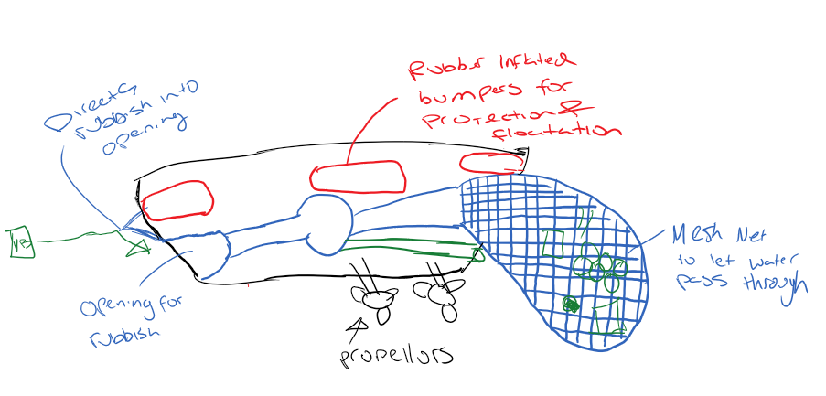

TOP VIEW:

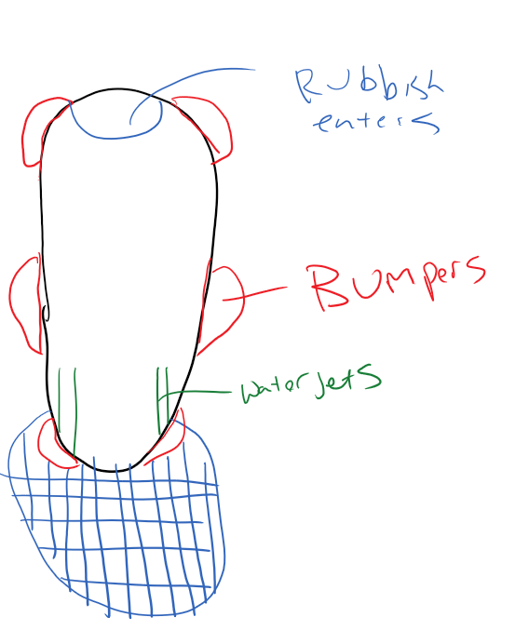

FRONT VIEW:

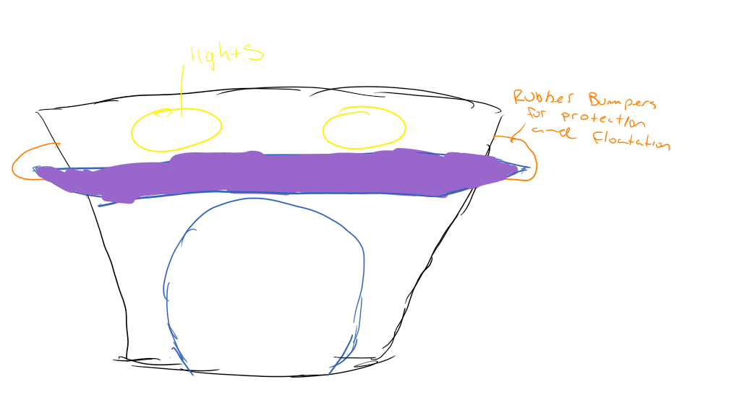

REAR VIEW:

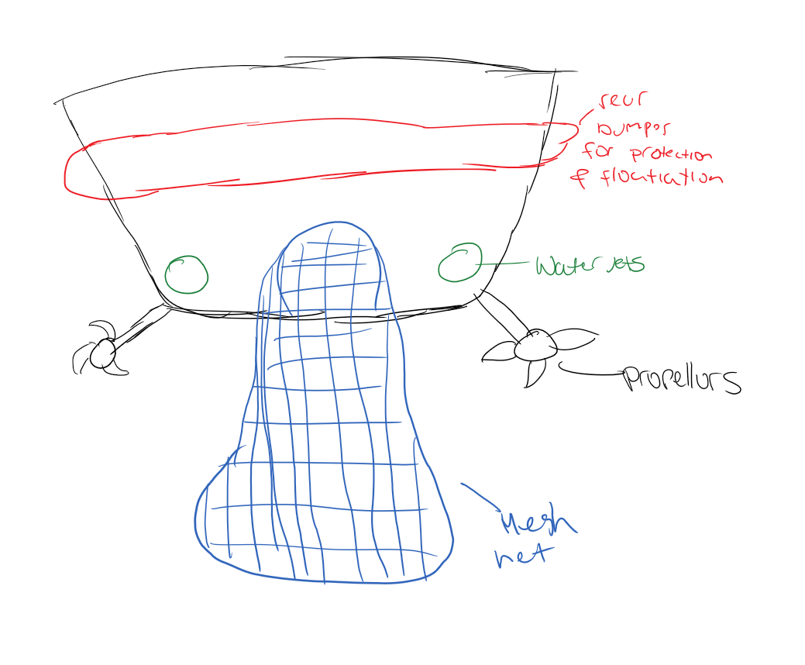

DOCKING STATION:

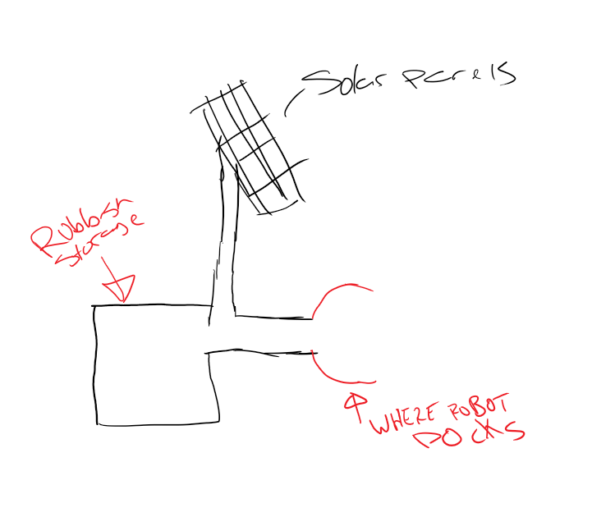

**Software Required**

The software required for the machine to operate would include:

* Programming the system to research weather conditions and effectively using that information to determine whether the robot would be sent out to collect rubbish or not.
* Programming the robot to know when its net is full of rubbish to then return to the docking station to store its contents inside the station's bin.
* Programming the sensors to communicate together to define the perimeter in which the robot would operate.
* A means of communication between the docking station and the robot to ensure cooperation between the two. If the robot is full of rubbish it will communicate to the station that it needs to dock. If the docking station is full of rubbish in its bin, it will communicate with the robot to stop collecting and to dock and await a user to collect the bin.
* A means of communication between the system and the user.

**Skills Required**

The biggest concern of this project is storing all that technology within hardware that could maintain and survive the weather conditions thrown at it. Rough sea water that would promote rust and deterioration, rain and winds, animals including but not limited to fishes, birds, sharks, etc.

the software required to operate the systems would include a lot of self-maintenance. The system would ideally operate effectively by itself by knowing when to charge, empty rubbish, dock etc. it’s a computer system that has a lot more variables than a Roomba would. Programming this system would require answers and solutions to many different factors mentioned above for it to operate effectively.

**Outcome**

In a perfect world, if this system was successful it would result in less rubbish in our oceans. Although it doesnâ€™t solve the ginormous issue of pollution and litter that earth currently faces, it sure does help tackle it. The use of sustainable energy also minimises the carbon footprint the system has on the planet in terms of using fossil fuel energy. If governments ever decide to invest more into cleaning up the planet as well, there would be even more robots around the world cleaning up. With government funding there could be more robots and less rubbish in the ocean killing marine life and polluting our planet.

To circle back on what I want to learn from RMIT as well, I would love to learn the skills required to start this project or something similar one day to help earth be a better place.

# REFERENCES:

Conservation International n.d,*OCEAN POLLUTION:11 FACTS YOU NEED TO KNOW*, Conservation International, viewed 26 March 2020,< [https://www.conservation.org/stories/ocean-pollution-11-facts-you-need-to-know](https://www.conservation.org/stories/ocean-pollution-11-facts-you-need-to-know/)>

Woodford,Chris 2009/2016,*Roomba robot vacuum cleaners*, ExplainThatStuff!, viewed 26 March 2020, < <https://www.explainthatstuff.com/how-roomba-works.html>>

Layton Julia, n.d,*How Robotic Vacuums Work*, How Stuff Works?, viewed 26 March 2020, < <https://electronics.howstuffworks.com/gadgets/home/robotic-vacuum2.htm>>

The Grand Tour presents: seamen, 2019, Amazon Prime Video, Amazon, n/a, Viewed 15th December 2019, <<https://www.primevideo.com/detail/0J82A1O4IWN8EXPFXBNT8W3E7T/ref=atv_hm_hom_c_8pZiqd_2_1>>